Acceptance tests   
Acme-Newspaper 2.0

|  |  |
| --- | --- |
| ****Development team**** | |
| **Identifier** | G69 |
| **Members** | Castaño, Carlos; Lozano, Ángel; Lucas, Ismael; Ortiz, Sergio; Pérez, Ángel; Reyes, Camila. |
| **Testing team** | |
| **Identifier** | G7 |
| **Members** | Alcalá, Guillermo; Calbet, María Victoria; Ortiz, Jesús; Ramírez, Marta; Romero, David; Utrilla, Juan Carlos. |
| **Indexing data** | |
| **Test designers** | Castaño, Carlos; Reyes, Camila |
| **Testers** | Castaño, Carlos; Reyes, Camila |
| **Notes** |  |

Table of contents

Use case UC01 Register as an user 4

Use case UC02 Create newspaper 5

Use case UC03 List published newspapers 7

Use case UC04 Create article 9

Use case UC05 Browse articles from newspaper 12

Use case UC06 List users 13

Use case UC07 Display users 14

Use case UC08 Search articles by keyword 15

Use case UC09 Search newspapers by keyword 17

Use case UC10 Remove article 18

Use case UC11 Remove newspaper 19

Use case UC12 Display dashboard 20

Use case UC12 Edit Terms and Conditions 22

Use case UC13 Create a Follow-Up 23

Use case UC14 Post a Chirp 24

Use case UC15 Follow/Unfollow another user 25

Use case UC16 List my following users. 27

Use case UC17 List my follower users. 28

Use case UC18 List the “Chirp Line”. 29

Use case UC19 Create taboo words 29

Use case UC20 Edit taboo words 31

Use case UC21 Delete taboo words 32

Use case UC22 List articles with taboo words 33

Use case UC23 List newspapers with taboo words 34

Use case UC24 List articles with taboo words 35

Use case UC25 Remove a chirp 36

Use case UC26 Remove a chirp 37

Use case UC27 Create a private Newspaper 38

Use case UC28 Publish a private Newspaper 38

Use case UC29 Display a private Newspaper 40

Use case UC30 Register as a Customer 41

Use case UC31 Subscribe to a private newspaper with valid Credit Card 42

Use case UC32 Decide that a newspaper is public or private 43

Use case UC33 Register as an agent 44

Use case UC34 Create advertisement in newspaper 46

Use case UC34 List newspaper in which agent has or not placed an advertisement 49

Use case UC35 List spam advertisement 51

Use case UC36 Delete advertisement 52

Use case UC37 List the volumes 53

Use case UC38 Subscribe a volume. 54

Use case UC39 Create a volume. 55

Use case UC40 Add a newspaper to a volume. 56

Use case UC41 Remove a newspaper from a volume. 57

Use case UC42 Send a message. 58

Use case UC43 Send a System Notification. 59

Use case UC44 Delete a message. 61

Use case UC45 Create a folder. 62

Use case UC46 Delete a folder. 63

Additional tests 64

User case UC48 Default Taboo Words 65

User case UC49 Display a private newspaper 66

Add a page with the following structure for each use case.

# Use case UC01 Register as an user

Description

An unauthenticated user wishes to register to the system; he or she fills in a form with personal data and user account data; finally he or she hits the ‘Register’ button.

Access

Main Menu > Submit as a User.

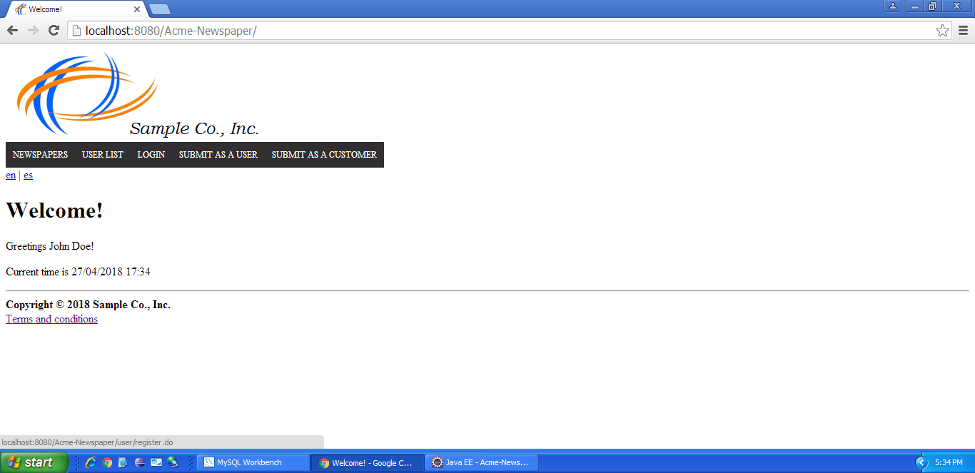

Tests

|  |  |
| --- | --- |
| **Test <#1>** | |
| **Description** | The form must not be filled |
| **Expected** | The system must return the form with the following errors: Username and password size must be from 5 to 32; name, surname and email must not be blank. |
| **Outcome** | It works as intended. |
| **Notes** | The main menu changed slightly compared to what’s shown in the screenshot, but I had no problem reaching the page. |

|  |  |
| --- | --- |
| **Test <#2>** | |
| **Description** | The form must be filled with the following data: Username: ‘user5’, password: ‘user5’, name: ‘Light’, surname: ‘Yagami’, e-mail: ‘ryuk@shinigami.es’. Terms and conditions checkbox must not be checked. |
| **Expected** | The system must show the following message: ‘You must accept our terms and conditions to sign up’ |
| **Outcome** | It works as expected. |
| **Notes** |  |

|  |  |
| --- | --- |
| **Test <#3>** | |
| **Description** | The form must be filled with the following data: Username: ‘user1’, password: ‘user1’, name: ‘Light’, surname: ‘Yagami’, e-mail: ‘ryuk@shinigami.es’. Terms and conditions checkbox must be checked. |
| **Expected** | The system must show the following message: ‘Username is already in use’ |
| **Outcome** | The outcome is correct. |
| **Notes** |  |

|  |  |
| --- | --- |
| **Test <#4>** | |
| **Description** | The form must be filled with the following data: Username: ‘user5’, password: ‘user5’, name: ‘Light’, surname: ‘Yagami’, e-mail: ‘ryuk@shinigami.es’. Terms and conditions checkbox must be checked. |
| **Expected** | The system must redirect to login page and it has to be possible to login to the system with the created user. |
| **Outcome** | It works as expected. |
| **Notes** |  |

# Use case UC02 Create newspaper

Description

An authenticated user wishes to create a newspaper.

Access

Main Menu > Login > Login with username and password ‘user1’ > Newspapers > Newspapers > Create.

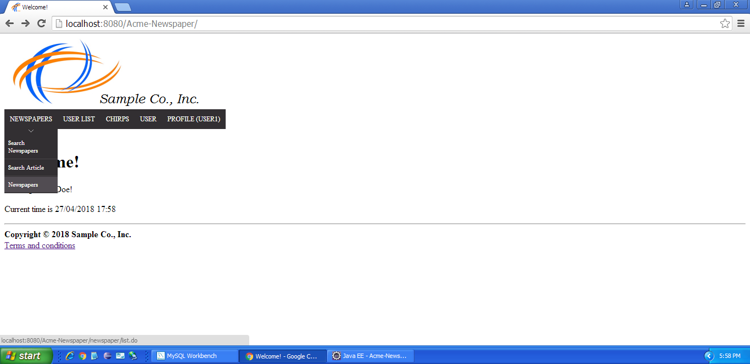

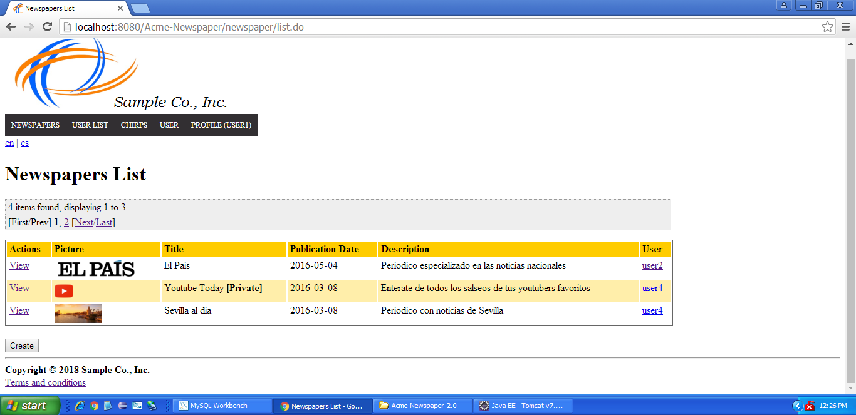

Tests

|  |  |
| --- | --- |
| **Test <#1>** | |
| **Description** | Click on “Save” button without fill the form. |
| **Expected** | The system must return the form with the following errors: Title and description must not be blank and price cannot be null. |
| **Outcome** | The outcome is correct. |
| **Notes** |  |

|  |  |
| --- | --- |
| **Test <#2>** | |
| **Description** | Fill the form with the following data: Title: ‘newspaper1’’, description: ‘description’, picture: ‘picture’, price: 0. |
| **Expected** | The system must return the form with the following error: Invalid URL on picture input. |
| **Outcome** | The outcome is correct. |
| **Notes** |  |

|  |  |
| --- | --- |
| **Test <#3>** | |
| **Description** | Fill the form with the following data: Title: ‘newspaper1’’, description: ‘description’, picture: ‘http://localhost:8080/Acme-Newspaper/images/logo.png’, price: 0. |
| **Expected** | The system must return the form with the following error: The price of a private newspaper must be greater than 0. |
| **Outcome** | ERROR: It allowed me to create a free private newspaper (this is, with a price value of 0.0). |
| **Notes** |  |

|  |  |
| --- | --- |
| **Test <#4>** | |
| **Description** | Fill the form with the following data: Title: ‘newspaper1’’, description: ‘description’, picture: ‘http://localhost:8080/Acme-Newspaper/images/logo.png’, public: enabled, price: 0. |
| **Expected** | The system must return the list of newspapers and newspaper1 must be part of that list. |
| **Outcome** | It works as expected. |
| **Notes** | For some reason, the image appears as “broken”, but the functionality works as expected. However, pagination seems to not work properly: when I browse the second page of newspapers, it shows newspapers which don’t belong to user1. |

|  |  |
| --- | --- |
| **Test <#5>** | |
| **Description** | Click on “Return” button. |
| **Expected** | The system must return the list of newspapers. |
| **Outcome** | It works as intended. |
| **Notes** |  |

# Use case UC03 List published newspapers

Description

An authenticated user wishes to list published newspapers.

Access

Main Menu > Login > Login with username and password ‘user1’ > Newspapers > Newspapers.



Tests

|  |  |
| --- | --- |
| **Test <#1>** | |
| **Description** |  |
| **Expected** | The system must return the list of the published newspapers. There are four newspapers, but three must be shown. Publication dates must be in the past. |
| **Outcome** |  |
| **Notes** |  |

|  |  |
| --- | --- |
| **Test <#2>** | |
| **Description** | Go to page 2 |
| **Expected** | Every pagination link must work fine. Page 2 must display two newspapers. |
| **Outcome** | It works as intended. |
| **Notes** |  |

|  |  |
| --- | --- |
| **Test <#3>** | |
| **Description** | Click “View” link in newspaper with title “El Pais”. |
| **Expected** | “El Pais” newspaper must be displayed. |
| **Outcome** | It works as expected. |
| **Notes** |  |

|  |  |
| --- | --- |
| **Test <#4>** | |
| **Description** | Click “user2” link in newspaper with title “El Pais”. |
| **Expected** | User2 profile must be displayed |
| **Outcome** | It works as expected. |
| **Notes** |  |

|  |  |
| --- | --- |
| **Test <#5>** | |
| **Description** | Click “Create” button. |
| **Expected** | Form to create a newspaper must be displayed. |
| **Outcome** | The outcome is correct. |
| **Notes** |  |

# Use case UC04 Create article

Description

An authenticated user wishes to create an article.

Access

Main Menu > Login > Login with username and password ‘user1’ > User > Create an Article > Create Article on newspaper with title ‘El Mundo’.

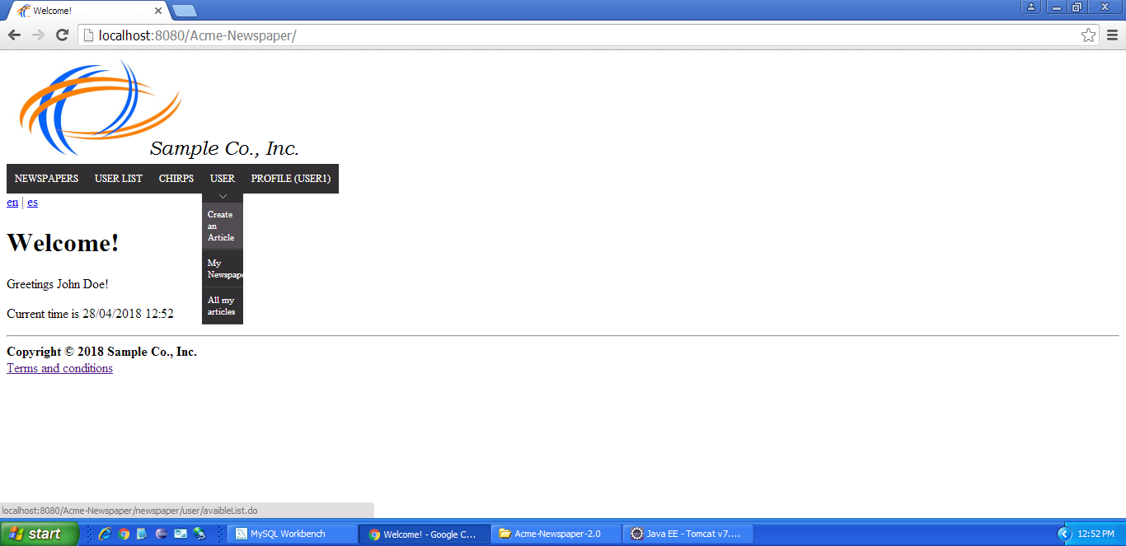

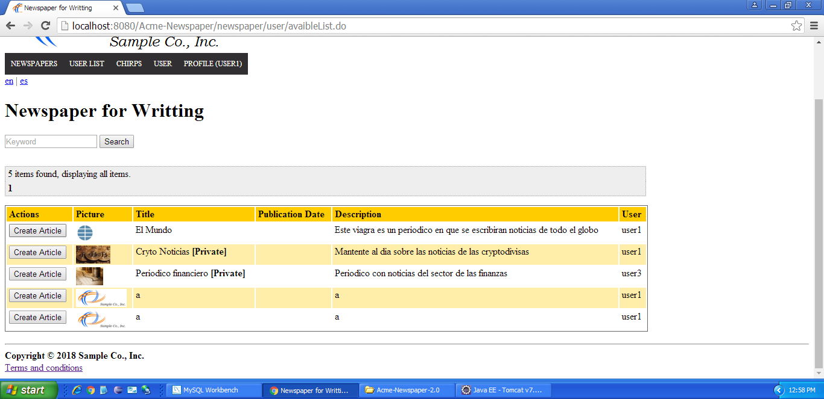

Tests

|  |  |
| --- | --- |
| **Test <#1>** | |
| **Description** | Click on “Save” button without fill the form. |
| **Expected** | The system must return the form with the following errors: Title, summary and description must not be blank. |
| **Outcome** | ERROR: the summary section shows no error message. |
| **Notes** |  |

|  |  |
| --- | --- |
| **Test <#2>** | |
| **Description** | Fill the form with the following data: Title: ‘article1’, summary: ‘summary’, description: ‘description’, pictures: ‘picture’. |
| **Expected** | The system must return the form with the following error: Invalid URL on picture input. |
| **Outcome** | It works as intended. |
| **Notes** |  |

|  |  |
| --- | --- |
| **Test <#3>** | |
| **Description** | Fill the form with the following data: Title: ‘newspaper1’, summary: ‘summary’, description: ‘description’, picture: ‘http://localhost:8080/Acme-Newspaper/images/logo.png’. |
| **Expected** | The system must return the articles list. |
| **Outcome** | It works as expected. |
| **Notes** |  |

|  |  |
| --- | --- |
| **Test <#4>** | |
| **Description** | Fill the form with the following data: Title: ‘newspaper1’’, description: ‘description’, picture: ‘http://localhost:8080/Acme-Newspaper/images/logo.png’, public: enabled, price: 0. |
| **Expected** | The system must return the list of newspapers and newspaper1 must be part of that list. |
| **Outcome** | ERROR: there is no “price” attribute in the article’s creation view. |
| **Notes** | This is likely an error made while copy-pasting the tests. |

|  |  |
| --- | --- |
| **Test <#5>** | |
| **Description** | Click on “Return” button. |
| **Expected** | The system must return the list of newspapers for writting. |
| **Outcome** | The outcome is correct. |
| **Notes** |  |

# Use case UC05 Browse articles from newspaper

Description

An authenticated user wishes to browse the articles of a newspaper

Access

Main Menu > Login > Login with username and password ‘user1’ > Newspapers > Newspapers.



Tests

|  |  |
| --- | --- |
| **Test <#1>** | |
| **Description** |  |
| **Expected** | The system must display the newspaper, including a table with its two articles. If summary has more than 50 characters, it must end with “…”. |
| **Outcome** | ERROR: the summary is not visible; only the title and the creator are shown. |
| **Notes** |  |

|  |  |
| --- | --- |
| **Test <#2>** | |
| **Description** | Click “View” in newspaper with title “Sevilla al dia”, click on title “La Giralda de Sevilla era roja (en una de sus caras)”. |
| **Expected** | The system must display the article. |
| **Outcome** | It works as expected. |
| **Notes** |  |

# Use case UC06 List users

Description

An authenticated user wishes to browse the users of the system.

Access

Main Menu > Login > Login with username and password ‘user1’ > ‘User List’.

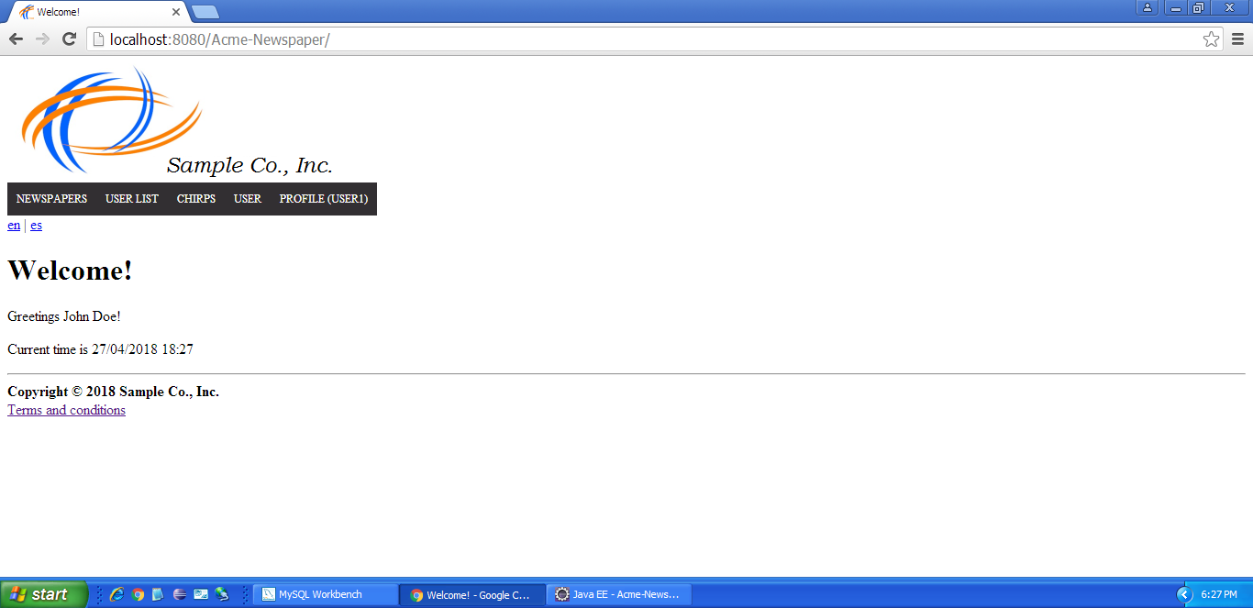

Tests

|  |  |
| --- | --- |
| **Test <#1>** | |
| **Description** |  |
| **Expected** | The system must return the list of the users. There are four users, but three must be shown. |
| **Outcome** | The outcome is correct. |
| **Notes** |  |

|  |  |
| --- | --- |
| **Test <#2>** | |
| **Description** | Go to page 2, |
| **Expected** | Every pagination link must work fine. Page 2 must display just an user. |
| **Outcome** | The outcome is correct. |
| **Notes** |  |

|  |  |
| --- | --- |
| **Test <#3>** | |
| **Description** | Click on any “See profile” link. |
| **Expected** | User profile must be displayed. |
| **Outcome** | The test’s outcome is correct. |
| **Notes** |  |

# Use case UC07 Display users

Description

An authenticated user wishes to display users profile.

Access

Main Menu > Login > Login with username and password ‘user1’ > ‘User List’.



Tests

|  |  |
| --- | --- |
| **Test <#1>** | |
| **Description** | Click on first “See profile” link. |
| **Expected** | The system must display the user profile. It must display a table with the user’s articles, in this case there are one article, and a table with the user’s chirps, in this case there are 6 chirps, but 5 are displayed in page 1. Publication date of articles must be in the past. |
| **Outcome** | ERROR: there are 5 articles displayed in the user’s profile. 1 is public and 4 are private. |
| **Notes** |  |

# Use case UC08 Search articles by keyword

Description

An authenticated user wishes search articles by a keyword.

Access

Main Menu > Login > Login with username and password ‘user1’ > ‘Newspaper’ > ‘Search article’.

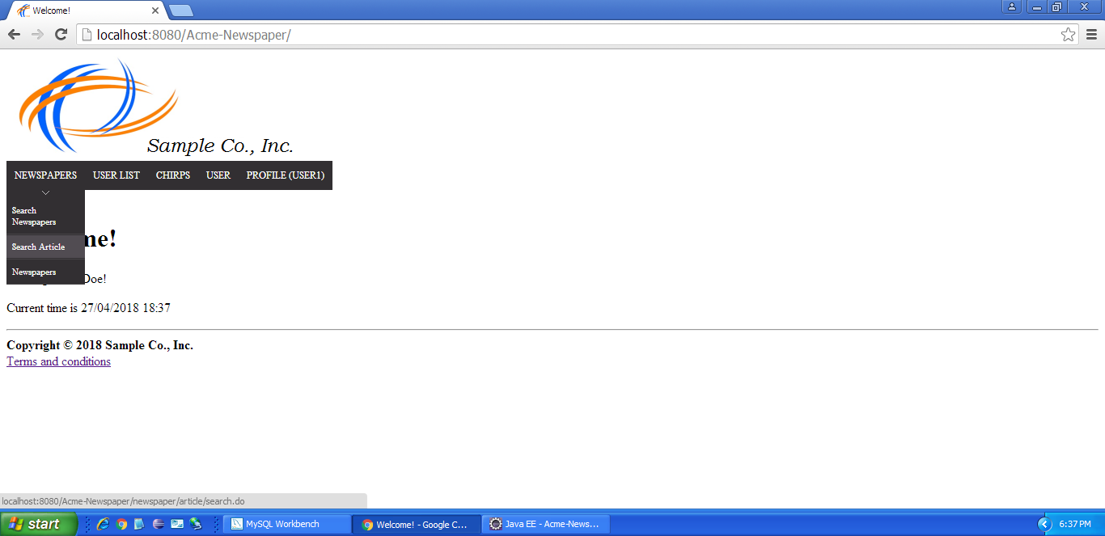

Tests

|  |  |
| --- | --- |
| **Test <#1>** | |
| **Description** | Click on “Search” button without introducing any keyword. |
| **Expected** | The system must return the list of all published articles. In this case there are 5 articles, but 4 are listed. Publication dates must be in the past. |
| **Outcome** | The returned number of articles is correct and the dates are in the past. |
| **Notes** | I am not sure if I should consider an ERROR the fact that the articles are completely empty besides the publication date. |

|  |  |
| --- | --- |
| **Test <#2>** | |
| **Description** | Go to page 2, click [First/Prev], click [Next/Last] |
| **Expected** | Every pagination link must work fine. Page 2 must display just an article. |
| **Outcome** | ERROR: there is no [First/Prev] or [Next/Last] link visible. |
| **Notes** |  |

|  |  |
| --- | --- |
| **Test <#3>** | |
| **Description** | Introduce “rector” as keyword and click on “Search” button. |
| **Expected** | Article with title “El rector de la Rey Juan Carlos deja sin coartada a Cristina Cifuentes” must be shown. |
| **Outcome** | ERROR: there is an article retrieved, but no information is given. There isn’t a link to click to check if the retrieved article is the expected one. |
| **Notes** |  |

|  |  |
| --- | --- |
| **Test <#4>** | |
| **Description** | Introduce “yagami” as keyword and click on “Search” button. |
| **Expected** | No articles must be displayed |
| **Outcome** | It works as expected. |
| **Notes** |  |

# Use case UC09 Search newspapers by keyword

Description

An authenticated user wishes search articles by a keyword.

Access

Main Menu > Login > Login with username and password ‘user1’ > ‘Newspaper’ > ‘Search Newspapers’.



Tests

|  |  |
| --- | --- |
| **Test <#1>** | |
| **Description** | Click on “Search” button without introducing any keyword. |
| **Expected** | The system must return the list of all published newspapers. In this case there are 5 newspapers, but 4 are listed. Publication dates must be in the past. |
| **Outcome** | ERROR: there are more than 5 newspapers displayed in the page. Not only that, there are more than 5 newspapers retrieved from the dabatase.      In addition, all but one of the newspapers are blank. |
| **Notes** | The description says that the user wants to search for articles, but the test targets searching for newspapers. |

|  |  |
| --- | --- |
| **Test <#2>** | |
| **Description** | Go to page 2, click [First/Prev], click [Next/Last] |
| **Expected** | Every pagination link must work fine. Page 2 must display just a newspaper. |
| **Outcome** | ERROR: the search bar has disappeared when I browsed page 2.    Also, the First/Prev and Next/Last links are not visible |
| **Notes** |  |

|  |  |
| --- | --- |
| **Test <#3>** | |
| **Description** | Introduce “youtube” as keyword and click on “Search” button. |
| **Expected** | Newspaper with title “Youtube Today” must be displayed. |
| **Outcome** | ERROR: every newspaper in the database is displayed, not only Youtube Today.    Also, the information columns except for Publication date and description are blank. |
| **Notes** |  |

|  |  |
| --- | --- |
| **Test <#4>** | |
| **Description** | Introduce “yagami” as keyword and click on “Search” button. |
| **Expected** | No newspapers must be displayed. |
| **Outcome** | ERROR: all the newspapers registered in the database are displayed. |
| **Notes** |  |

# Use case UC10 Remove article

Description

The admin of the system wishes to remove an article.

Access

Main Menu > Login > Login with username and password ‘admin’ > ‘Newspaper’ > ‘Search Article’ > Click on “Search button” with empty form > Click “Display” button on first listed article.

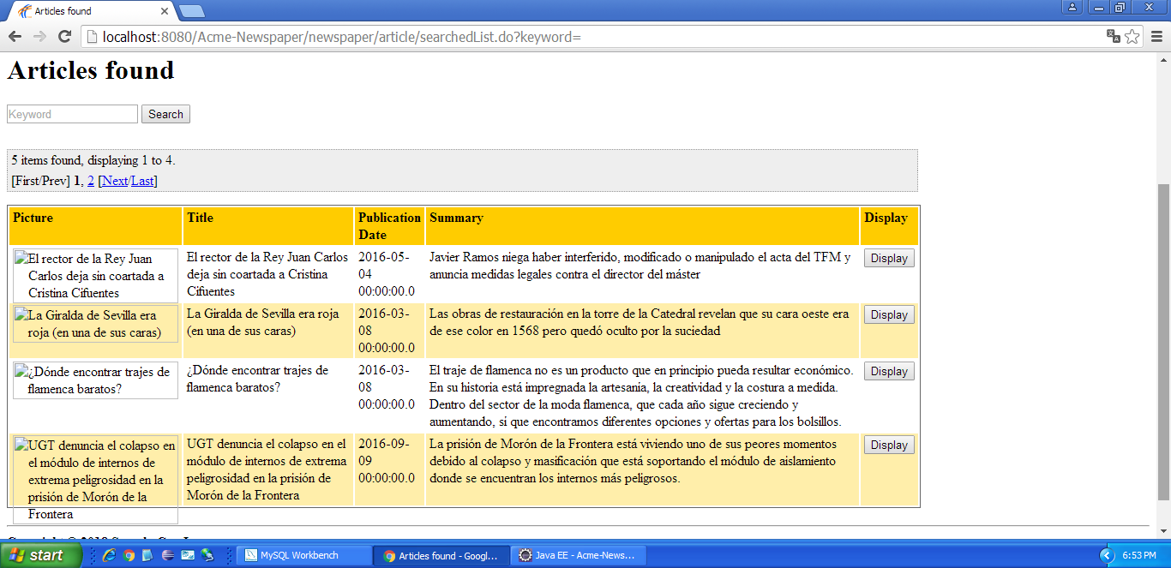

Tests

|  |  |
| --- | --- |
| **Test <#1>** | |
| **Description** | Click on “Delete” button. |
| **Expected** | The system must display the corresponding newspaper. |
| **Outcome** | It works as expected. |
| **Notes** |  |

# Use case UC11 Remove newspaper

Description

The admin of the system wishes to remove an newspaper.

Access

Main Menu > Login > Login with username and password ‘admin’ > ‘Newspaper’ > ‘Newspapers’ > Click on “View” link in “Sevilla al dia” newspaper.

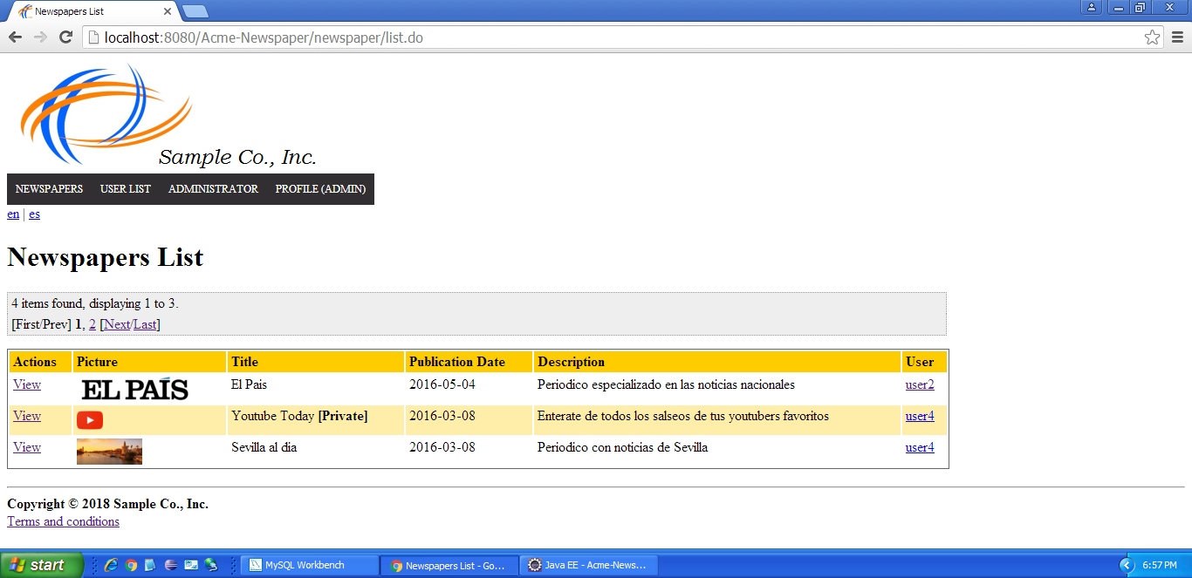

Tests

|  |  |
| --- | --- |
| **Test <#1>** | |
| **Description** | Click on “Delete” button. |
| **Expected** | The system must display newspapers list, and “Sevilla al dia” newspaper must not be in that list. After display all articles (Newspaper>Search Article> Empty form and Search), articles with title “La Giralda de Sevilla era roja (en una de sus caras)” and “¿Dónde encontrar trajes de flamenca baratos?” must not be in that list. |
| **Outcome** | ERROR: the delete button redirects to the newspaper instead of deleting it. |
| **Notes** |  |

# Use case UC12 Display dashboard

Description

The admin of the system wishes to display the dashboard.

Access

Main Menu > Login > Login with username and password ‘admin’ > ‘Administrator’ > ‘Dashboard’.

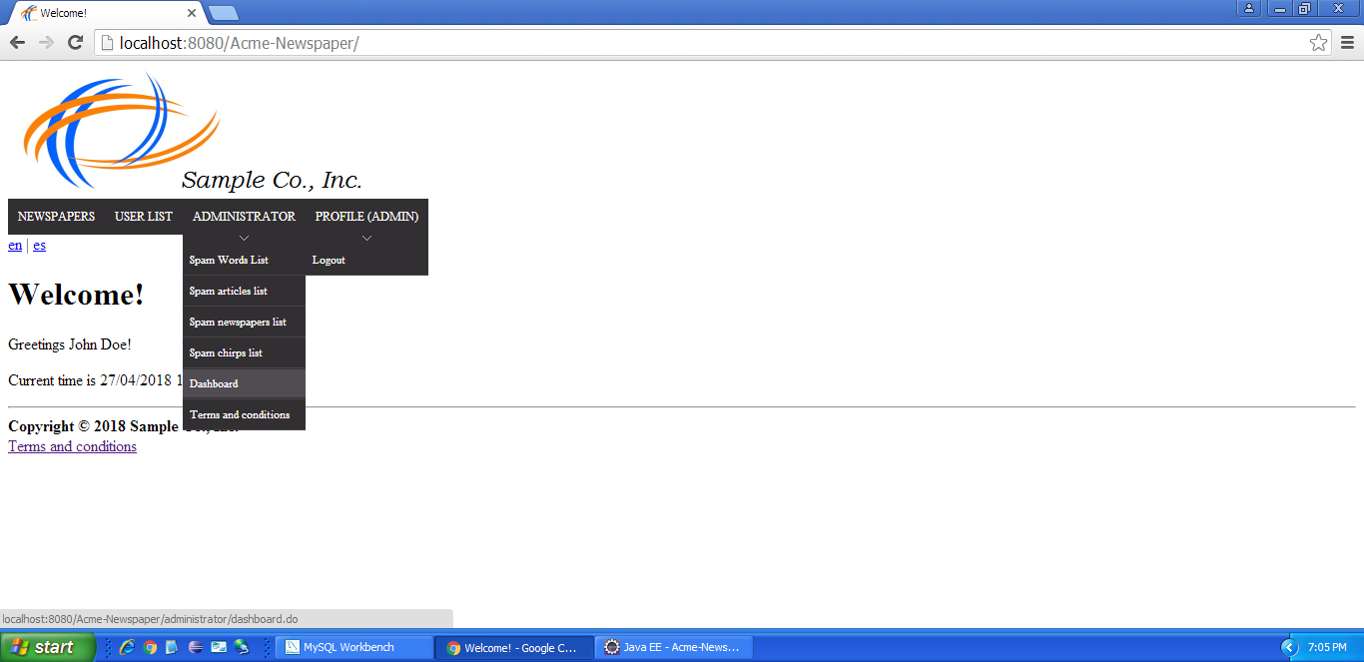

Tests

|  |  |
| --- | --- |
| **Test <#1>** | |
| **Description** |  |
| **Expected** | Dashboard must be displayed. |
| **Outcome** | It works as intended. |
| **Notes** |  |

# Use case UC12 Edit Terms and Conditions

Description

The admin of the system wishes to edit terms and conditions.

Access

Main Menu > Login > Login with username and password ‘admin’ > ‘Administrator’ > ‘Terms and Conditions’.



Tests

|  |  |
| --- | --- |
| **Test <#1>** | |
| **Description** | Click on “Edit” button in Terms and Conditions, and then click “Cancel”. |
| **Expected** | Legal Texts must be displayed. |
| **Outcome** | It works as expected. |
| **Notes** |  |

|  |  |
| --- | --- |
| **Test <#2>** | |
| **Description** | Click on “Edit” button in Terms and Conditions, make any modification and then click “Save”. |
| **Expected** | Legal Texts must be displayed. |
| **Outcome** | It works as intended. |
| **Notes** |  |

|  |  |
| --- | --- |
| **Test <#3>** | |
| **Description** | Click on “Edit” button in Cookies, and then click “Cancel”. |
| **Expected** | Legal Texts must be displayed. |
| **Outcome** | The outcome is correct. |
| **Notes** |  |

|  |  |
| --- | --- |
| **Test <#4>** | |
| **Description** | Click on “Edit” button in Cookies, make any modification and then click “Save”. |
| **Expected** | Legal Texts must be displayed. |
| **Outcome** | The expected outcome is correct. |
| **Notes** |  |

# Use case UC13 Create a Follow-Up

Description

The creator of a published article wishes to create a follow-up to complete it with an extra information. He or she fills the correspondent areas and clicks “save”.

Access

Main Menú > User > All my articles > Display > See follow-ups > Create follow-up

Tests

For every test that you wish the tester to perform, include a table with the following structure. Check your theory lecture notes to learn about some typical test

|  |  |
| --- | --- |
| **Test <#1>** | |
| **Description** | The only user who can create an actor must be the writer of the article. The areas of ‘Title’ and ‘Description’ are obligatory and the area of ‘URL of optional pictures’ must start with “www. THEURL” and separated by ‘ , ‘. |
| **Expected** | The system must return the user to the follow-up list of the named article and showing the follow-up that we have created before. |
| **Outcome** | ERROR: the follow-up was created despite the picture field being filled with a non-url element. Not only that, the button to create new follow-ups is missing. |
| **Notes** |  |

|  |  |
| --- | --- |
| **Test <#2>** | |
| **Description** | The user only fill the part of title, letting the description’s area empty. |
| **Expected** | The system must return an error message explaining that we need the description box full too with words. |
| **Outcome** | It works as intended. |
| **Notes** |  |

|  |  |
| --- | --- |
| **Test <#3>** | |
| **Description** | The user only fill the part of description, letting the title’s area empty |
| **Expected** | The system must return an error message explaining that we need the title box full too with words. |
| **Outcome** | The outcome is correct. |
| **Notes** |  |

# Use case UC14 Post a Chirp

Description

A user can post a chirp including the regarding information and then clicking to “save”.

Access

Main Menu > Chirps > Create

Tests

|  |  |
| --- | --- |
| **Test <#1>** | |
| **Description** | The user must post a chirp including the information in Title and description. |
| **Expected** | The system must return the user to the chirps list that the user will see in this Chirp-Line. |
| **Outcome** | ERROR: an XSS injection can be made when entering XSS code in the description of the chirp. |
| **Notes** |  |

|  |  |
| --- | --- |
| **Test <#2>** | |
| **Description** | The user only fill the part of title, letting the description’s area empty. |
| **Expected** | The system must return an error message explaining that we need the description box full too with words. |
| **Outcome** | The outcome is correct. |
| **Notes** |  |

|  |  |
| --- | --- |
| **Test <#3>** | |
| **Description** | The user only fill the part of description, letting the title’s area empty |
| **Expected** | The system must return an error message explaining that we need the title box full too with words. |
| **Outcome** | The result is correct. |
| **Notes** |  |

# Use case UC15 Follow/Unfollow another user

Description

A user of the system can have followers and he/she can follow to other users for seeing their chirps at current time.

Access

Main Menu > Profile > Display User > Followers / Following > See Profile > Follow / Unfollow

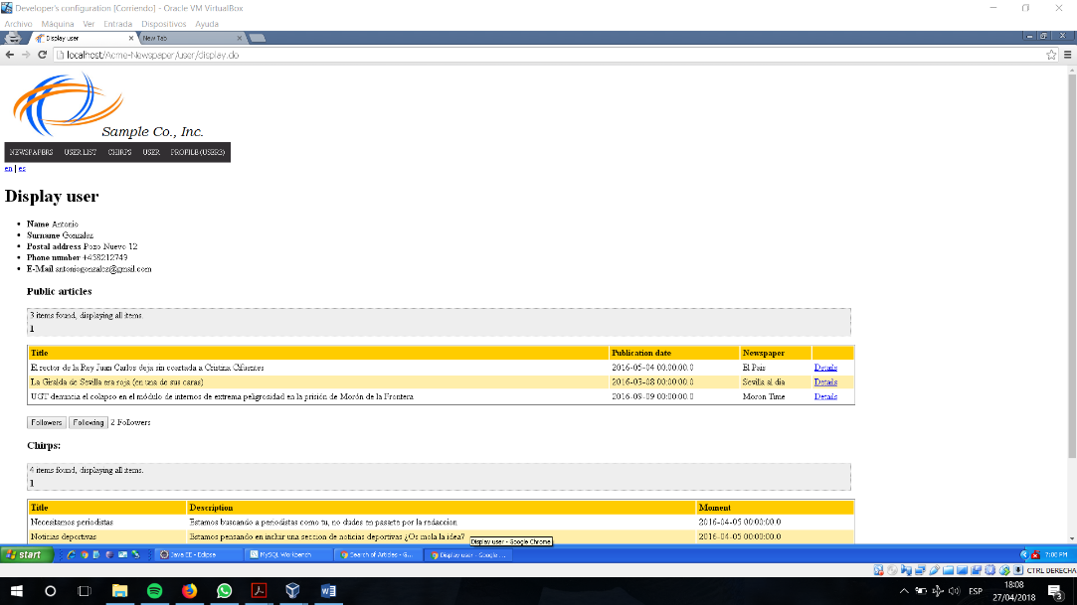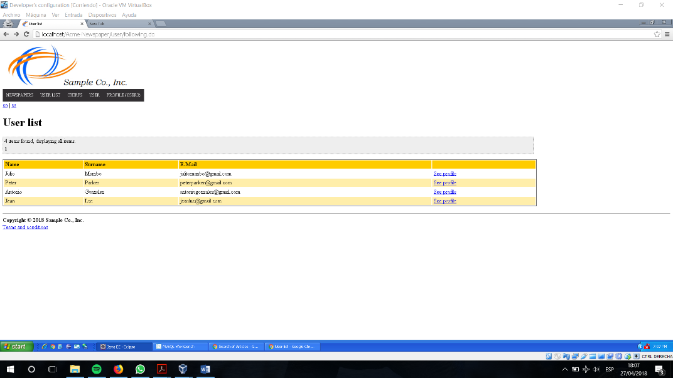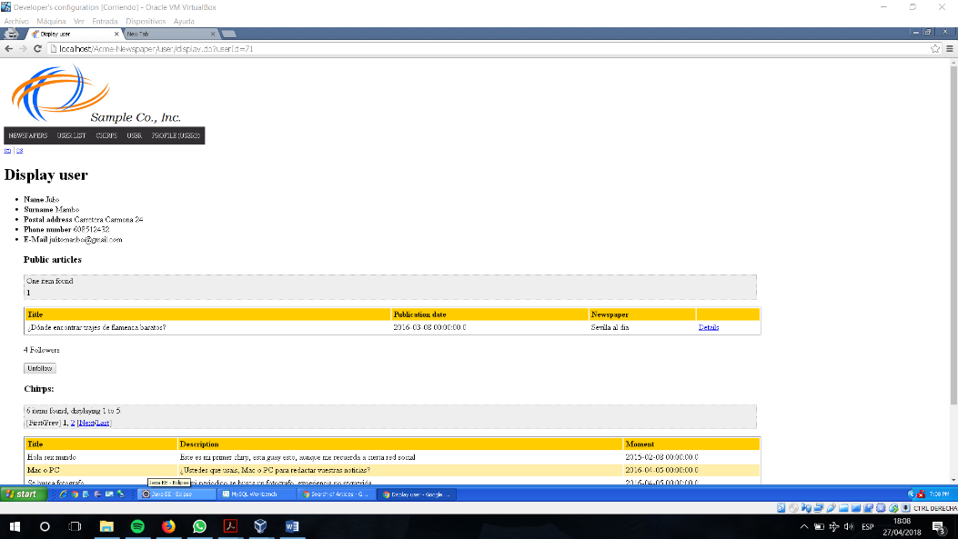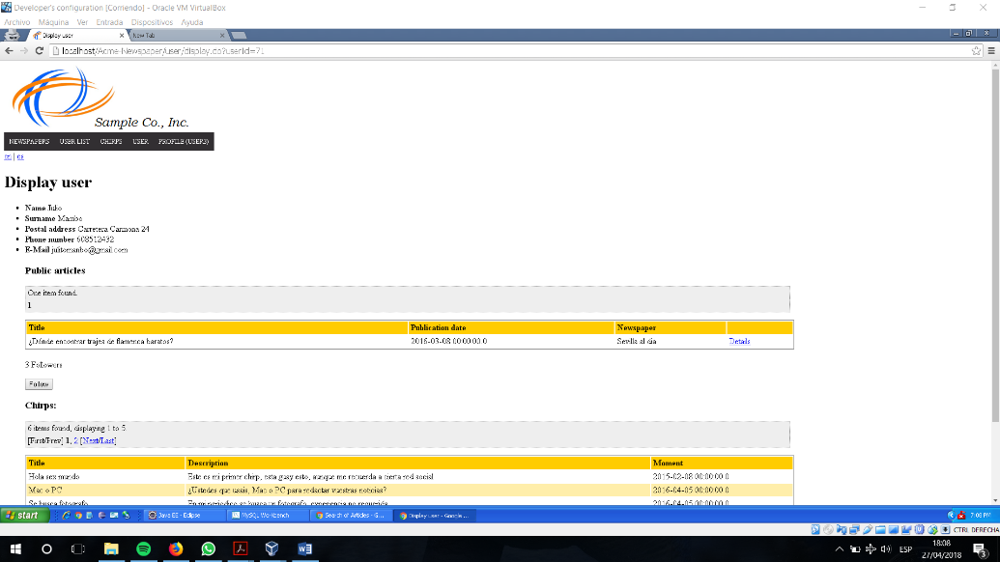

Tests

|  |  |
| --- | --- |
| **Test <#1>** | |
| **Description** | The user can follow and unfollow the user with only clicking the correspondent button. |
| **Expected** | The user can see that his number of ‘followings’ increase and decrease. We can see the same in ‘followers’ for the other person. |
| **Outcome** | It works as expected. |
| **Notes** |  |

# Use case UC16 List my following users.

Description

A user can see the list of users that he follows to see their chirps

Access

Main Menú > User > Display User > Following

Tests

|  |  |
| --- | --- |
| **Test <#1>** | |
| **Description** | A login user enters with normality in his profile and click on the list, then it will appear. |
| **Expected** | The system must return a table with name, surname, email and the action to see their profile. |
| **Outcome** | ERROR: The following button is not visible after following the instructions. |
| **Notes** | When doing the test following the path User list -> See profile -> Following it works properly. |

|  |  |
| --- | --- |
| **Test <#2>** | |
| **Description** | A non-authenticated user try to enter by URL on the list of following user. |
| **Expected** | The system must return the user to the login view. |
| **Outcome** | It works as intended. |
| **Notes** |  |

# Use case UC17 List my follower users.

Description

A user can see the list of users that are following him/her to see his/her chirps

Access

Main Menú > User > Display User > Followers

Tests

|  |  |
| --- | --- |
| **Test <#1>** | |
| **Description** | A login user enters with normality in his profile and click on the list, then it will appear. |
| **Expected** | The system must return a table with name, surname, email and the action to see their profile. |
| **Outcome** | It works as intended. |
| **Notes** |  |

|  |  |
| --- | --- |
| **Test <#2>** | |
| **Description** | A non-authenticated user try to enter by URL on the list of follower users. |
| **Expected** | The system must return the user to the login view. |
| **Outcome** | The outcome is correct. |
| **Notes** |  |

# Use case UC18 List the “Chirp Line”.

Description

A user can see the chirps that he and his followings are writing in order of creation.

Access

Main Menú > Chirp

Tests

|  |  |
| --- | --- |
| **Test <#1>** | |
| **Description** | A login user enters in the system with normality to see the current chirps of him and his followings. |
| **Expected** | The system must return a list with the user, the moment, the title and the description. |
| **Outcome** | It works as intended. |
| **Notes** |  |

|  |  |
| --- | --- |
| **Test <#2>** | |
| **Description** | A non-authenticated user try to enter by URL on the list of chirps. |
| **Expected** | The system must return the user to the login view. |
| **Outcome** | The outcome is correct. |
| **Notes** |  |

# Use case UC19 Create taboo words

Description

An administrator of the system can create new taboo words.

Access

Login as Administrator > Main Menu > Administrator > Spamwords List > Create

Tests

|  |  |
| --- | --- |
| **Test <#1>** | |
| **Description** | A login administrator enters to the spam words list and create an spam word filling the name box. |
| **Expected** | The system must return a list of spam words where our spam word it’s contained in. |
| **Outcome** | It works as intended. |
| **Notes** |  |

|  |  |
| --- | --- |
| **Test <#2>** | |
| **Description** | A login administrator enters to the spam words list and create an spam word without filling the name box. |
| **Expected** | The system must return a control error message showing that this box need to be filled with a string. |
| **Outcome** | The outcome is correct. |
| **Notes** |  |

|  |  |
| --- | --- |
| **Test <#3>** | |
| **Description** | A non-authenticated user tries to enter by URL on the create spam words view, the system must show de login view. |
| **Expected** | The system must return the user to the login view. |
| **Outcome** | The result is correct. |
| **Notes** |  |

|  |  |
| --- | --- |
| **Test <#4>** | |
| **Description** | An authenticated different role tries to enter by URL on the create spam words view, the system must show the login view. |
| **Expected** | The system must show a view explaining that he/she has not access to that view. |
| **Outcome** | ERROR: an agent can enter a zone that should be restricted only to the administrators. |
| **Notes** |  |

# Use case UC20 Edit taboo words

Description

An administrator of the system can edit current taboo words.

Access

Login as Administrator > Main Menu > Administrator > Spamwords List > Edit

Tests

|  |  |
| --- | --- |
| **Test <#1>** | |
| **Description** | A login administrator enters to the spam words list and edit a spam word filling the name box. |
| **Expected** | The system must return a list of spam words where our spam word it contained in. |
| **Outcome** | It works as expected. |
| **Notes** |  |

|  |  |
| --- | --- |
| **Test <#2>** | |
| **Description** | A login administrator enters to the spam words list and edit an spam word without filling the name box. |
| **Expected** | The system must return a control error message showing that this box need to be filled with an string. |
| **Outcome** | The outcome is correct. |
| **Notes** |  |

|  |  |
| --- | --- |
| **Test <#3>** | |
| **Description** | A non-authenticated user tries to enter by URL on the edit spam words view, the system must show de login view. |
| **Expected** | The system must return the user to the login view. |
| **Outcome** | The outcome is correct. |
| **Notes** |  |

|  |  |
| --- | --- |
| **Test <#4>** | |
| **Description** | An authenticated different role tries to enter by URL on the edit spam words view, the system must show de login view. |
| **Expected** | The system must show a view explaining that he/she has not access to that view. |
| **Outcome** | ERROR: an agent can edit the spam words. |
| **Notes** |  |

# Use case UC21 Delete taboo words

Description

An administrator of the system can edit current taboo words.

Access

Login as Administrator > Main Menu > Administrator > Spam words List > Edit > Delete

Tests

|  |  |
| --- | --- |
| **Test <#1>** | |
| **Description** | A login administrator enters to the view of editing a spam word and click the button ‘delete’ |
| **Expected** | The system must return a list of spam words where our spam word it’s not contained in. |
| **Outcome** | It works as expected. |
| **Notes** |  |

|  |  |
| --- | --- |
| **Test <#2>** | |
| **Description** | A login administrator enters to the spam words list and edit an spam word without filling the name box. |
| **Expected** | The system must return a control error message showing that this box need to be filled with a string. |
| **Outcome** | It works as expected. |
| **Notes** |  |

|  |  |
| --- | --- |
| **Test <#3>** | |
| **Description** | A non-authenticated user tries to enter by URL on the edit spam words view, the system must show de login view. |
| **Expected** | The system must return the user to the login view. |
| **Outcome** | The response is correct. |
| **Notes** |  |

|  |  |
| --- | --- |
| **Test <#4>** | |
| **Description** | An authenticated different role tries to enter by URL on the edit spam words view, the system must show de login view. |
| **Expected** | The system must show a view explaining that he/she has not access to that view. |
| **Outcome** | ERROR: an agent can delete spam words; only the administrators should be allowed to do that. |
| **Notes** |  |

# Use case UC22 List articles with taboo words

Description

An administrator of the system can see the articles that contains taboo words.

Access

Login as Administrator > Main Menu > Administrator > Spam Article List

Tests

|  |  |
| --- | --- |
| **Test <#1>** | |
| **Description** | A login administrator enters to the view of articles with spam words |
| **Expected** | The system must return a list of articles with the title of the article and the link to see that article. |
| **Outcome** | It works as intended. |
| **Notes** |  |

|  |  |
| --- | --- |
| **Test <#2>** | |
| **Description** | A non-authenticated user tries to enter by URL on article spam words list. |
| **Expected** | The system must return the user to the login view. |
| **Outcome** | The outcome is correct. |
| **Notes** |  |

|  |  |
| --- | --- |
| **Test <#3>** | |
| **Description** | An authenticated different role tries to enter by URL on article spam words list.. |
| **Expected** | The system must show a view explaining that he/she has not access to that view. |
| **Outcome** | The outcome is correct. |
| **Notes** |  |

# Use case UC23 List newspapers with taboo words

Description

An administrator of the system can see the newspapers that contains taboo words.

Access

Login as Administrator > Main Menu > Administrator > Spam Newspaper List

Tests

|  |  |
| --- | --- |
| **Test <#1>** | |
| **Description** | A login administrator enters to the view of newspapers with spam words |
| **Expected** | The system must return a list of newspapers with the title of the newspaper and the link to see that newspaper. |
| **Outcome** | The outcome is correct. |
| **Notes** |  |

|  |  |
| --- | --- |
| **Test <#2>** | |
| **Description** | A non-authenticated user tries to enter by URL on newspapers spam words list. |
| **Expected** | The system must return the user to the login view. |
| **Outcome** | The result is what the team expected it to be. |
| **Notes** |  |

|  |  |
| --- | --- |
| **Test <#3>** | |
| **Description** | An authenticated different role tries to enter by URL on newspapers spam words list. |
| **Expected** | The system must show a view explaining that he/she has not access to that view. |
| **Outcome** | The result is correct. |
| **Notes** |  |

# Use case UC24 List articles with taboo words

Description

An administrator of the system can see the chirps that contains taboo words.

Access

Login as Administrator > Main Menu > Administrator > Spam Chirps List

Tests

|  |  |
| --- | --- |
| **Test <#1>** | |
| **Description** | A login administrator enters to the view of chirps with spam words |
| **Expected** | The system must return a list of chirps with the title of the chirps and the link to delete that chirps. |
| **Outcome** | The outcome is correct. |
| **Notes** |  |

|  |  |
| --- | --- |
| **Test <#2>** | |
| **Description** | A non-authenticated user tries to enter by URL on chirps spam words list. |
| **Expected** | The system must return the user to the login view. |
| **Outcome** | The outcome is correct. |
| **Notes** |  |

|  |  |
| --- | --- |
| **Test <#3>** | |
| **Description** | An authenticated different role tries to enter by URL on chirps spam words list. |
| **Expected** | The system must show a view explaining that he/she has not access to that view. |
| **Outcome** | The result is correct. |
| **Notes** |  |

# Use case UC25 Remove a chirp

Description

An administrator of the system can delete a chirp who he thinks it is inappropiate.

Access

Login as Administrator > Main Menu > Administrator > Spam Chirps List > Delete

Tests

|  |  |
| --- | --- |
| **Test <#1>** | |
| **Description** | A login administrator enters to the view of chirps with spam words and delete a chirp. |
| **Expected** | The system must return a list of chirps with the title of the chirps and the link to delete that chirps without the chirp that has been deleted before. |
| **Outcome** | The outcome is correct. |
| **Notes** |  |

|  |  |
| --- | --- |
| **Test <#2>** | |
| **Description** | A non-authenticated user tries to enter by URL on chirps spam words list. |
| **Expected** | The system must return the user to the login view. |
| **Outcome** | The outcome is correct. |
| **Notes** |  |

|  |  |
| --- | --- |
| **Test <#3>** | |
| **Description** | An authenticated different role tries to enter by URL on chirps spam words list. |
| **Expected** | The system must show a view explaining that he/she has not access to that view. |
| **Outcome** | The test returns the expected outcome. |
| **Notes** |  |

# Use case UC26 Remove a chirp

Description

An administrator of the system can delete a chirp who he thinks it is inappropiate.

Access

Login as Administrator > Main Menu > Administrator > Spam Chirps List > Delete

Tests

|  |  |
| --- | --- |
| **Test <#1>** | |
| **Description** | A login administrator enters to the view of chirps with spam words and delete a chirp. |
| **Expected** | The system must return a list of chirps with the title of the chirps and the link to delete that chirps without the chirp that has been deleted before. |
| **Outcome** | The outcome is correct. |
| **Notes** |  |

|  |  |
| --- | --- |
| **Test <#2>** | |
| **Description** | A non-authenticated user tries to enter by URL on chirps spam words list. |
| **Expected** | The system must return the user to the login view. |
| **Outcome** | The outcome is correct. |
| **Notes** |  |

|  |  |
| --- | --- |
| **Test <#3>** | |
| **Description** | An authenticated different role tries to enter by URL on chirps spam words list. |
| **Expected** | The system must show a view explaining that he/she has not access to that view. |
| **Outcome** | The result is correct. |
| **Notes** |  |

# Use case UC27 Create a private Newspaper

Description

A user can create a newspaper as a private one.

Access

Login as User > Main Menu > Newspapers > Newspapers > Create

Tests

|  |  |
| --- | --- |
| **Test <#1>** | |
| **Description** | A login user can create a newspaper filling all the boxes correctly (title, description, the box of public non-ticked and a price more than zero). |
| **Expected** | The system must return a list of my newspapers where the before one is included. |
| **Outcome** | ERROR: it is possible to create a private newspaper which is free (this is, with a price value of 0.0, and even with negative numbers). |
| **Notes** |  |

|  |  |
| --- | --- |
| **Test <#2>** | |
| **Description** | A non-authenticated user tries to enter by URL on chirps spam words list. |
| **Expected** | The system must return the user to the login view. |
| **Outcome** | --- |
| **Notes** | This test is unrelated to the entity under test. Either ways, an anonymous user can’t enter the newspaper edition view. |

|  |  |
| --- | --- |
| **Test <#3>** | |
| **Description** | An authenticated different role tries to enter by URL on chirps spam words list. |
| **Expected** | The system must show a view explaining that he/she has not access to that view. |
| **Outcome** | --- |
| **Notes** | This test is unrelated to the entity under test. Still, no one except users can enter the newspaper edition view. |

# Use case UC28 Publish a private Newspaper

Description

A user can save a newspaper as a private one.

Access

Login as User > Main Menu > User > My Newspapers > View > Publish

Tests

|  |  |
| --- | --- |
| **Test <#1>** | |
| **Description** | A login user can publish his private newspaper if all their articles are saved as final mode. |
| **Expected** | The system must return a list of his/her newspapers, where the named before now is published. |
| **Outcome** | It works as intended. |
| **Notes** |  |

|  |  |
| --- | --- |
| **Test <#2>** | |
| **Description** | A login user tries to publish his private newspaper and not all their articles are saved as final mode. |
| **Expected** | The system must not show the button for clicking it to publish. |
| **Outcome** | It works as intended. |
| **Notes** |  |

|  |  |
| --- | --- |
| **Test <#3>** | |
| **Description** | A login user tries to publish a private newspaper that is not from him/her changing the newspaperId by url. |
| **Expected** | The system must redirect him/her to newspaper’s List. |
| **Outcome** | Works as intended. |
| **Notes** |  |

|  |  |
| --- | --- |
| **Test <#3>** | |
| **Description** | A non-authenticated user tries to publish a private newspaper. |
| **Expected** | The system must return the user to the login view. |
| **Outcome** | The result is correct. |
| **Notes** |  |

|  |  |
| --- | --- |
| **Test <#4>** | |
| **Description** | An authenticated different role tries to enter by URL to publish a private newspaper. |
| **Expected** | The system must show a view explaining that he/she has not access to that view or has been redirected to another view. |
| **Outcome** | The outcome is correct. |
| **Notes** |  |

# Use case UC29 Display a private Newspaper

Description

A login subscribed customer can display a private newspaper.

Access

Login as Customer > Main Menu > Newspaper > Newspapers > View

Tests

|  |  |
| --- | --- |
| **Test <#1>** | |
| **Description** | A login customer and subscribed can display a private newspaper |
| **Expected** | The system must return the display of the newspaper with the article list and the information of this newspaper. |
| **Outcome** | The outcome is correct. |
| **Notes** |  |

|  |  |
| --- | --- |
| **Test <#2>** | |
| **Description** | A login customer and not subscribed tries to display a private newspaper. |
| **Expected** | The system must show a view for create a new inscription for that private newspaper. |
| **Outcome** | RELLENAR |
| **Notes** |  |

|  |  |
| --- | --- |
| **Test <#3>** | |
| **Description** | A login user tries to display a private newspaper by URL. |
| **Expected** | The system must not show the privates articles and the required information. |
| **Outcome** | The system brings the user to the welcome page, so it doesn’t show any information.  RELLENAR: UN ADMIN PUEDE ENTRAR |
| **Notes** |  |

|  |  |
| --- | --- |
| **Test <#4>** | |
| **Description** | A non-authenticated user tries to display a private newspaper. |
| **Expected** | The system must not show the privates articles and the required information. |
| **Outcome** | Works as intended. The unauthenticated user is brought to the welcome page. |
| **Notes** |  |

# Use case UC30 Register as a Customer

Description

A non-authenticated user can register as a Customer on the system.

Access

Main menu > Submit as a Customer

Tests

|  |  |
| --- | --- |
| **Test <#1>** | |
| **Description** | The actor must fill the username, the password, name, surname, postal address (optional), phone number (optional) and e-mail (correctly) and tick de terms and conditions. |
| **Expected** | The system must return to the view of login to the system. |
| **Outcome** | Works as intended. |
| **Notes** |  |

|  |  |
| --- | --- |
| **Test <#2>** | |
| **Description** | The actor not fill the user name/password/name or surname. |
| **Expected** | The system must return an error message for not letting it/them as blank. |
| **Outcome** | The outcome is correct. |
| **Notes** |  |

|  |  |
| --- | --- |
| **Test <#3>** | |
| **Description** | The actor not tick the terms and conditions. |
| **Expected** | The system must return an error message for not letting it without the tick. |
| **Outcome** | It works as intended. |
| **Notes** |  |

|  |  |
| --- | --- |
| **Test <#4>** | |
| **Description** | The actor not enter the e-mail correctly. |
| **Expected** | The system must return an error message for write it correctly as the pattern. |
| **Outcome** | It works as expected. |
| **Notes** |  |

# Use case UC31 Subscribe to a private newspaper with valid Credit Card

Description

A login customer can subscribe into a private newspaper with a valid credit.

Access

Login as Customer > Main menu > Newspapers > Newspapers > View > Suscribe

Tests

|  |  |
| --- | --- |
| **Test <#1>** | |
| **Description** | The customer can subscribe filling all the areas correctly: number, holder name, CVV code, expiration month and expiration year. |
| **Expected** | The system must return to the view of newspapers list. |
| **Outcome** | It works as intended. |
| **Notes** |  |

|  |  |
| --- | --- |
| **Test <#2>** | |
| **Description** | The customer tries to subscribe not filling the areas correctly: number/holder name/ CVV code/ expiration month or expiration year. |
| **Expected** | The system must return an error message for not letting it/them as blank or putting in the correct pattern. |
| **Outcome** | It works as expected. |
| **Notes** |  |

|  |  |
| --- | --- |
| **Test <#3>** | |
| **Description** | The customer tries to subscribe with an expired credit card |
| **Expected** | The system must return an error message telling that it is expired. |
| **Outcome** | The error message was correctly shown. |
| **Notes** |  |

|  |  |
| --- | --- |
| **Test <#4>** | |
| **Description** | A non-authenticated actor tries to subscribe in a private newspaper by URL. |
| **Expected** | The system must return a view of login on the system. |
| **Outcome** | The result is correct. |
| **Notes** |  |

|  |  |
| --- | --- |
| **Test <#5>** | |
| **Description** | A login different role tries to subscribe in a private newspaper by URL. |
| **Expected** | The system must return a view telling him/her of not having access to that view. |
| **Outcome** | It works as expected. |
| **Notes** |  |

# Use case UC32 Decide that a newspaper is public or private

A writer of a newspaper can decide if her/his newspaper is public or private before of publish it.

Access

Login as User > Main menu > User > My Newspapers > View > Edit

Tests

|  |  |
| --- | --- |
| **Test <#1>** | |
| **Description** | The user can edit the newspaper before of publishing it and tick on the box for public or let it blank for privatized it, then click the button “save”. |
| **Expected** | The system must return to the view of newspapers list created by this user and show the state of that newspaper. |
| **Outcome** | It works as expected. |
| **Notes** |  |

# Use case UC33 Register as an agent

Description

An unauthenticated user wishes to register to the system as an agent; he or she fills in a form with personal data and user account data; finally he or she hits the ‘Register’ button.

Access

Main Menu > Submit > Submit as an Agent.

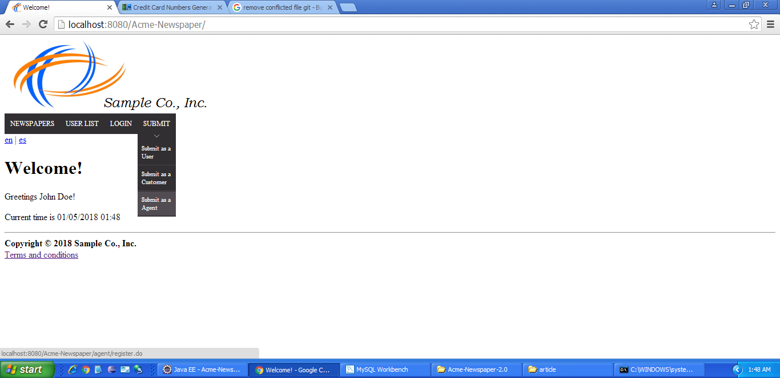

Tests

|  |  |
| --- | --- |
| **Test <#1>** | |
| **Description** | The form must not be filled |
| **Expected** | The system must return the form with the following errors: Username and password size must be from 5 to 32; name, surname and email must not be blank. |
| **Outcome** | The error messages are correctly displayed. |
| **Notes** |  |

|  |  |
| --- | --- |
| **Test <#2>** | |
| **Description** | The form must be filled with the following data: Username: ‘agent5’, password: ‘agent5’, name: ‘Light’, surname: ‘Yagami’, e-mail: ‘ryuk@shinigami.es’. Terms and conditions checkbox must not be checked. |
| **Expected** | The system must show the following message: ‘You must accept our terms and conditions to sign up’ |
| **Outcome** | The outcome is correct. |
| **Notes** |  |

|  |  |
| --- | --- |
| **Test <#3>** | |
| **Description** | The form must be filled with the following data: Username: ‘agent1’, password: ‘agent1’, name: ‘Light’, surname: ‘Yagami’, e-mail: ‘ryuk@shinigami.es’. Terms and conditions checkbox must be checked. |
| **Expected** | The system must show the following message: ‘Username is already in use’ |
| **Outcome** | It works as expected. |
| **Notes** |  |

|  |  |
| --- | --- |
| **Test <#4>** | |
| **Description** | The form must be filled with the following data: Username: ‘agent5’, password: ‘agent5’, name: ‘Light’, surname: ‘Yagami’, e-mail: ‘ryuk@shinigami.es’. Terms and conditions checkbox must be checked. |
| **Expected** | The system must redirect to login page and it has to be possible to login to the system with the created agent. |
| **Outcome** | The login was performed successfully. |
| **Notes** |  |

# Use case UC34 Create advertisement in newspaper

Description

An agent wishes to create and advertisement and to place it in a newspaper. The agent chooses the newspaper and then creates the advertisement.

Access

Main Menu > Login > Login with username and password ‘agent1’ > Agent > Newspapers list > Place Advertisement in newspaper with title ‘El Pais’.

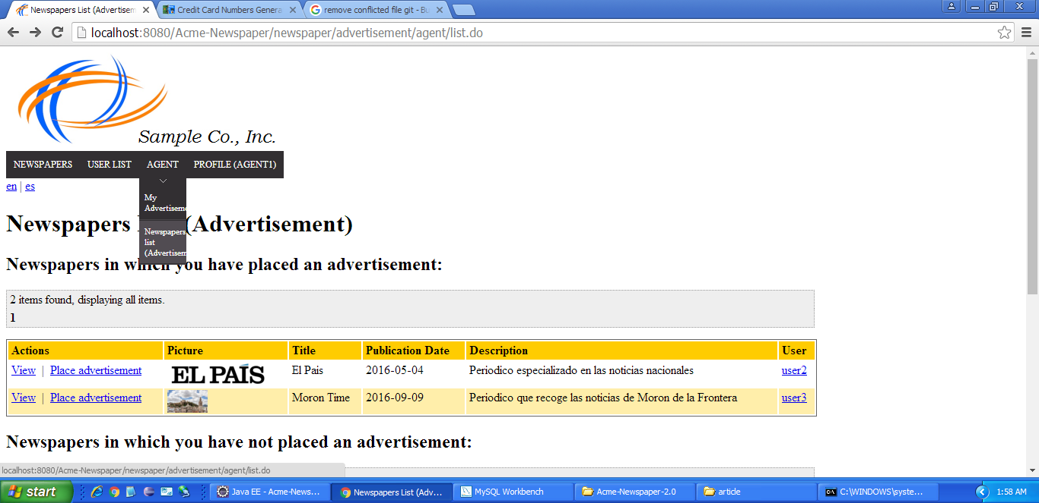

Tests

|  |  |
| --- | --- |
| **Test <#1>** | |
| **Description** | The form must not be filled |
| **Expected** | The system must return the form with the following errors: |
| **Outcome** | The error messages are displayed correctly. |
| **Notes** |  |

|  |  |
| --- | --- |
| **Test <#2>** | |
| **Description** | The form must be filled with the following data: Title: ‘ad1’, picture: ‘http://localhost:8080/Acme-Newspaper/images/logo.png’, URL: ‘http://www.google.es’, price: 10, number: 4024007102527024, holder name: ‘Visa’, CVV Code: ‘123’, expiration month: 05, expiration year: ‘2018’. |
| **Expected** | The system must show the following message: ‘Credit card has expired (it must not expire during the current month).’ |
| **Outcome** | ERROR: the error messages are displayed incorrectly. The error regarding the expiration year and the expiration month aren’t placed correctly. The labels were likely swapped. |
| **Notes** |  |

|  |  |
| --- | --- |
| **Test <#3>** | |
| **Description** | Click on ‘Return’ button. |
| **Expected** | The system must display the newspapers list. |
| **Outcome** | It works as expected. |
| **Notes** |  |

|  |  |
| --- | --- |
| **Test <#4>** | |
| **Description** | The form must be filled with the following data: Title: ‘ad1’, picture: ‘http://localhost:8080/Acme-Newspaper/images/logo.png’, URL: ‘http://www.google.es’, price: 10, number: 4024007102527024, holder name: ‘Visa’, CVV Code: ‘123’, expiration month: 05, expiration year: ‘2019. |
| **Expected** | The system must redirect to the list of the user advertisements.  The advertisement that has been created must be in that list. |
| **Outcome** | It works as intended. |
| **Notes** |  |

|  |  |
| --- | --- |
| **Test <#5>** | |
| **Description** | Logout of the system and log in with username and password ‘agent2’. Try to get into ‘http://localhost:8080/Acme-Newspaper/advertisement/agent/edit.do?advertisementId=423. |
| **Expected** | The system must display a list with the advertisements of the agent. That list is empty. |
| **Outcome** | ERROR: Agent2 doesn’t exist within the database. Therefore, I can’t login as that agent unless I create it myself.  RELLENAR |
| **Notes** |  |

# Use case UC34 List newspaper in which agent has or not placed an advertisement

Description

An agent wishes to list the newspapers in which has or not placed an advertisement.

Access

Main Menu > Login > Login with username and password ‘agent1’ > Agent > Newspapers list.



|  |  |
| --- | --- |
| **Test <#1>** | |
| **Description** |  |
| **Expected** | The system must display the newspapers list. |
| **Outcome** | The outcome is correct. |
| **Notes** |  |

|  |  |
| --- | --- |
| **Test <#2>** | |
| **Description** | In Newspapers in which you have not placed an advertisement list, click on page 2, then click on ‘Previous’ button, then click on ‘Next’ button. |
| **Expected** | Every pagination link must work fine. Page 2 must display just a newspaper. |
| **Outcome** | The outcome is correct. |
| **Notes** |  |

|  |  |
| --- | --- |
| **Test <#3>** | |
| **Description** | Click on any “View” link. |
| **Expected** | The newspaper must be displayed. |
| **Outcome** | The newspapers are displayed correctly. |
| **Notes** |  |

|  |  |
| --- | --- |
| **Test <#4>** | |
| **Description** | Click on ‘user2’ link. |
| **Expected** | The profile of user2 must be displayed. |
| **Outcome** | The profile is displayed as expected. |
| **Notes** |  |

# Use case UC35 List spam advertisement

Description

The admin of the system wishes to list the advertisements that contains taboo words in title.

Access

Main Menu > Login > Login with username and password ‘admin’ > ‘Administrator’ > ‘Spam advertisement list’.

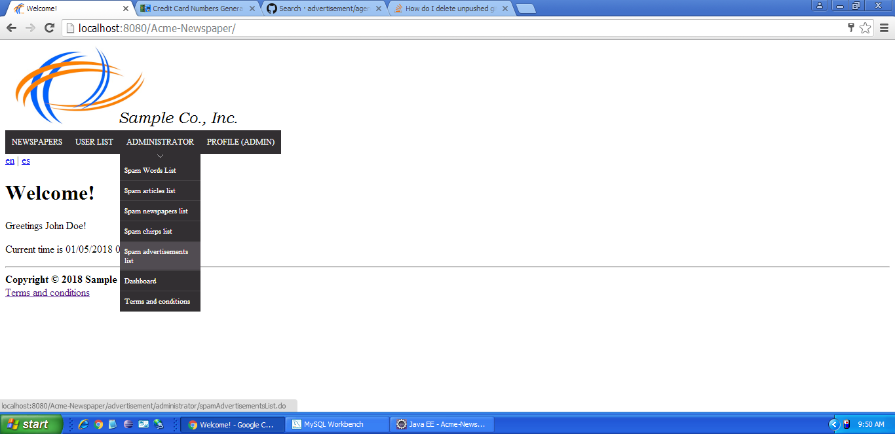

Tests

|  |  |
| --- | --- |
| **Test <#1>** | |
| **Description** |  |
| **Expected** | The system must return the list of advertisement with taboo words in title. One advertisement must be shown. |
| **Outcome** | ERROR: No advertisements are shown in the list, despite the fact that agent1 actually has an advertisement which contains a taboo word. |
| **Notes** |  |

# Use case UC36 Delete advertisement

Description

The admin of the system wishes to delete an advertisement that is innapropiate.

Access

Main Menu > Login > Login with username and password ‘admin’ > ‘Administrator’ > ‘Spam advertisement list’.



Tests

|  |  |
| --- | --- |
| **Test <#1>** | |
| **Description** | Click on ‘Delete’ link. |
| **Expected** | The system must return the list of advertisement with taboo words in title. No advertisements must be shown. |
| **Outcome** | It works as expected. |
| **Notes** |  |

|  |  |
| --- | --- |
| **Test <#2>** | |
| **Description** | Logout of the system and log in with username and password ‘user1’. Try to get into ‘http://localhost:8080/Acme-Newspaper/advertisement/administrator/spamAdvertisementsList.do’. |
| **Expected** | The system must display a message in which it is said that you don’t have access to the resource. |
| **Outcome** | ERROR: I receive a Google error regarding an error connection refusal. |
| **Notes** |  |

# Use case UC37 List the volumes

Description

An actor can list the available volumes of the system, depending of his role and state.

Access

Main menu > Newspapers > Volumes/Volumes (I’m not subscribed)

Tests

|  |  |
| --- | --- |
| **Test <#1>** | |
| **Description** | A non-authenticated actor can see the final volumes of the system. |
| **Expected** | The system must return a list of volumes where are shown the creator, the title, the description, the price and a link to the newspapers that form part on that volume. |
| **Outcome** | It works as expected. |
| **Notes** |  |

|  |  |
| --- | --- |
| **Test <#2>** | |
| **Description** | A customer actor can see the final volumes of the system. |
| **Expected** | The system must return a list of volumes where are shown the creator, the title, the description, the price and a link to the newspapers that form part on that volume. |
| **Outcome** | It works as intended. |
| **Notes** | Despite not being mentioned as a column which must appear, I assume that the section “Subscribe” is supposed to be displayed. |

|  |  |
| --- | --- |
| **Test <#3>** | |
| **Description** | An agent can see the final volumes of the system. |
| **Expected** | The system must return a list of volumes where are shown the creator, the title, the description, the price and a link to the newspapers that form part on that volume. |
| **Outcome** | It works as expected. |
| **Notes** |  |

|  |  |
| --- | --- |
| **Test <#4>** | |
| **Description** | An administrator can see the final volumes of the system. |
| **Expected** | The system must return a list of volumes where are shown the creator, the title, the description, the price and a link to the newspapers that form part on that volume. |
| **Outcome** | It works as expected. |
| **Notes** |  |

# Use case UC38 Subscribe a volume.

Description

A customer can subscribe a volume of newspaper paying with a valid credit card.

Access

Login as Customer > Main menu > Newspapers > Volumes (I’m not subscribed) > Subscribe

Tests

|  |  |
| --- | --- |
| **Test <#1>** | |
| **Description** | A customer can subscribe into a volume of newspaper if he introduces a valid credit card. |
| **Expected** | The system must return a list of volumes the customer is subscribed to. |
| **Outcome** | It works as intended. |
| **Notes** |  |

|  |  |
| --- | --- |
| **Test <#2>** | |
| **Description** | A customer tries to subscribe by URL to another newspaper that he has been subscribed before with a valid credit card. |
| **Expected** | The system must return a error message telling that he7she has been subscribed before, so the system stop de operation. |
| **Outcome** | The message is displayed successfully. |
| **Notes** |  |

|  |  |
| --- | --- |
| **Test <#3>** | |
| **Description** | A customer tries to subscribe introducing an invalid credit card. |
| **Expected** | The system must return error messages showing the errors for fixing them and make a correct operation of subscription. |
| **Outcome** | The error messages are displayed successfully. |
| **Notes** |  |

|  |  |
| --- | --- |
| **Test <#4>** | |
| **Description** | A different role tries to subscribe by URL to a publicated volume. |
| **Expected** | The system must return him/her into a view showing that he/she has not access to that resource. |
| **Outcome** | It worked as expected. |
| **Notes** |  |

# Use case UC39 Create a volume.

Description

A user can create a volume with his own newspapers.

Access

Login as User > Main menu > My created volumes > Create

Tests

|  |  |
| --- | --- |
| **Test <#1>** | |
| **Description** | A user creates a volume filling the correct values of the title, description and price (>0.0). |
| **Expected** | The system must return a list of volumes that he/she created and the last one created must be in the list. |
| **Outcome** | The volume is created successfully. |
| **Notes** |  |

|  |  |
| --- | --- |
| **Test <#2>** | |
| **Description** | A user creates a volume without filling the values of the title or description. |
| **Expected** | The system must return an error message telling that those boxes can’t be empty. |
| **Outcome** | The error messages are displayed correctly. |
| **Notes** |  |

|  |  |
| --- | --- |
| **Test <#3>** | |
| **Description** | A user creates a volume filling a negative or zero value on the price box. |
| **Expected** | The system must return error messages showing that the price must be positive. |
| **Outcome** | It works as intended. |
| **Notes** |  |

# Use case UC40 Add a newspaper to a volume.

Description

The creator of a newspaper can add newspaper to its volumes.

Access

Login as User > Main menu > My created volumes > Click here > Add To my Volumes > Save

Tests

|  |  |
| --- | --- |
| **Test <#1>** | |
| **Description** | A user can add a newspaper to his/her volumes. |
| **Expected** | The system must return a list of volumes that he/she created and the last one created must be in the list. |
| **Outcome** | It works as intended. |
| **Notes** |  |

|  |  |
| --- | --- |
| **Test <#2>** | |
| **Description** | A user tries to add again the same newspaper to the same volume. |
| **Expected** | The system must return a castrated list where that volume doesn’t appear. |
| **Outcome** | It works as intended. |
| **Notes** |  |

|  |  |
| --- | --- |
| **Test <#3>** | |
| **Description** | A user without volumes tries to add a newspaper by URL to a volume. |
| **Expected** | The system must return a view with a message telling him/her if he wants to create a volume for adding that newspaper because the system already know that this user has not anyone. |
| **Outcome** | The result is correct. |
| **Notes** |  |

|  |  |
| --- | --- |
| **Test <#4>** | |
| **Description** | A user tries to hack by post the different volumes to add the newspaper. |
| **Expected** | The system must return an error message telling him/her that this volume is not form his/her property. |
| **Outcome** | It works as expected. |
| **Notes** |  |

# Use case UC41 Remove a newspaper from a volume.

Description

The creator of a newspaper can add newspaper to its volumes.

Access

Login as User > Main menu > My created volumes > Click here > Add To my Volumes > Save

Tests

|  |  |
| --- | --- |
| **Test <#1>** | |
| **Description** | A user can remove correctly a newspaper from his/her volume. |
| **Expected** | The system must return a list of newspaper that this volume has, where that newspaper now doesn’t appear. |
| **Outcome** |  |
| **Notes** |  |

|  |  |
| --- | --- |
| **Test <#2>** | |
| **Description** | A user tries to hack by post the different newspapersId for removing from the volume. |
| **Expected** | The system must return an error message telling him/her that this newspaper is not from that volume. |
| **Outcome** |  |
| **Notes** |  |

|  |  |
| --- | --- |
| **Test <#3>** | |
| **Description** | A user tries to hack by post removing twice the same newspaper from the volume. |
| **Expected** | The system must return an error message telling him/her that this newspaper is not from that volume. |
| **Outcome** |  |
| **Notes** |  |

|  |  |
| --- | --- |
| **Test <#4>** | |
| **Description** | A user tries to hack by post the different volumeId for removing a newspaper from it. |
| **Expected** | The system must return an error message telling him/her that this volume is not of his/her property. |
| **Outcome** |  |
| **Notes** |  |

# Use case UC42 Send a message.

Description

An authenticated actor can send a message to another actor.

Access

Login > Main menu > Profile > Send New message > Save

Tests

|  |  |
| --- | --- |
| **Test <#1>** | |
| **Description** | A user can send a message to another user or him/herself. We fill the recipient correctly, the priority and the subject and description are not blank. |
| **Expected** | The system must return to a view where shows the outbox folder with a list of messages where it’s included the last one written. |
| **Outcome** |  |
| **Notes** |  |

|  |  |
| --- | --- |
| **Test <#2>** | |
| **Description** | A user tries to include by post a user with an Id that doesn’t exist. |
| **Expected** | The system must return an error message telling him/her that can not commit that operation. |
| **Outcome** |  |
| **Notes** |  |

|  |  |
| --- | --- |
| **Test <#3>** | |
| **Description** | A user tries to include by post a priority that doesn’t exist |
| **Expected** | The system must return an error message telling him/her that can not commit that operation. |
| **Outcome** |  |
| **Notes** |  |

|  |  |
| --- | --- |
| **Test <#4>** | |
| **Description** | A user let the box of subject/description blank. |
| **Expected** | The system must return an error message showing that hose boxes need to be filled. |
| **Outcome** |  |
| **Notes** |  |

|  |  |
| --- | --- |
| **Test <#5>** | |
| **Description** | A non-authenticated user tries to enter by URL to the message creation sending. |
| **Expected** | The system must return him/her to the view of login into the system. |
| **Outcome** |  |
| **Notes** |  |

# Use case UC43 Send a System Notification.

Description

An administrator of the system can send a notification of the system to all members of the application (users, agents, administrators and customers).

Access

Login as Administrator> Main menu > Profile > Folders > Send Notification > Save

Tests

|  |  |
| --- | --- |
| **Test <#1>** | |
| **Description** | An administrator can send a notification filling the boxes of subject and body and clinking in the type of priority that it has. |
| **Expected** | The system must return to a view where shows the outbox folder with a list of messages where it’s included the last one written. |
| **Outcome** |  |
| **Notes** |  |

|  |  |
| --- | --- |
| **Test <#2>** | |
| **Description** | An administrator tries to send it without filling the subject and/or the body. |
| **Expected** | The system must return an error message showing that hose boxes need to be filled. |
| **Outcome** |  |
| **Notes** |  |

|  |  |
| --- | --- |
| **Test <#3>** | |
| **Description** | A user tries to include by post a priority that doesn’t exist |
| **Expected** | The system must return an error message telling him/her that can not commit that operation. |
| **Outcome** |  |
| **Notes** |  |

|  |  |
| --- | --- |
| **Test <#4>** | |
| **Description** | An authenticated actor tries to enter by URL to the notification creation sending. |
| **Expected** | The system must return him/her to the view of creating a normal message. |
| **Outcome** |  |
| **Notes** |  |

|  |  |
| --- | --- |
| **Test <#5>** | |
| **Description** | A non-authenticated actor tries to enter by URL to the notification creation sending. |
| **Expected** | The system must return him/her to the view of login into the system. |
| **Outcome** |  |
| **Notes** |  |

# Use case UC44 Delete a message.

Description

An authenticated actor can delete a message from his/her folders.

Access

Login > Main menu > Profile > Folders > Open > Edit > Delete

Tests

|  |  |
| --- | --- |
| **Test <#1>** | |
| **Description** | A user can click on a normal folder (not trash box) and edit a message, then click into ‘Delete’ |
| **Expected** | The system must return to a view of trash box where are the deleted messages. |
| **Outcome** |  |
| **Notes** |  |

|  |  |
| --- | --- |
| **Test <#2>** | |
| **Description** | A user can click in trash box folder and delete the message, removing it from the system. |
| **Expected** | The system must return to the trash box view showing the list of messages moved to the rubbish without the message named before. |
| **Outcome** |  |
| **Notes** |  |

|  |  |
| --- | --- |
| **Test <#3>** | |
| **Description** | A user tries to delete by post the message from a normal folder that is not from his/her property. |
| **Expected** | The system must return an error message telling him/her that can not commit that operation. |
| **Outcome** |  |
| **Notes** |  |

# Use case UC45 Create a folder.

Description

An authenticated actor can create a new folder.

Access

Login > Main menu > Profile > Folders > Create

Tests

|  |  |
| --- | --- |
| **Test <#1>** | |
| **Description** | A user can create a new folder as a root folder (without any parent), filling the box of name. |
| **Expected** | The system must return to a view of the list of folders that the user has where the named one it’s included. |
| **Outcome** |  |
| **Notes** |  |

|  |  |
| --- | --- |
| **Test <#2>** | |
| **Description** | A user can create a folder as a son of another folder (without the same name). |
| **Expected** | The system must return to a view of the list of folders that the user has where the named one it’s included. |
| **Outcome** |  |
| **Notes** |  |

|  |  |
| --- | --- |
| **Test <#3>** | |
| **Description** | A user tries to create a root folder with the same name of another folder root. |
| **Expected** | The system must return an error message telling him/her that can not commit that operation. |
| **Outcome** |  |
| **Notes** |  |

­­

|  |  |
| --- | --- |
| **Test <#4>** | |
| **Description** | A user tries to create a son folder with the same name of its parent’s name. |
| **Expected** | The system must return an error message telling him/her that can not commit that operation. |
| **Outcome** |  |
| **Notes** |  |

|  |  |
| --- | --- |
| **Test <#5>** | |
| **Description** | A user tries to create a son folder hacking by post the parent folder id, using an id of another user folder. |
| **Expected** | The system must return an error trace. |
| **Outcome** |  |
| **Notes** |  |

# Use case UC46 Delete a folder.

Description

An authenticated actor can delete a folder of his property.

Access

Login > Main menu > Profile > Folders > Edit > Delete

Tests

|  |  |
| --- | --- |
| **Test <#1>** | |
| **Description** | A user deletes a non-system folder. |
| **Expected** | The system must return to a view of the list of folders that the user has where the named one it’s not included. |
| **Outcome** |  |
| **Notes** |  |

|  |  |
| --- | --- |
| **Test <#2>** | |
| **Description** | A user tries to edit/delete a system folder. |
| **Expected** | The system must not show the button correspondent to that folder.. |
| **Outcome** |  |
| **Notes** |  |

|  |  |
| --- | --- |
| **Test <#3>** | |
| **Description** | A user tries to edit/delete a system folder by POST. |
| **Expected** | The system must return an error message telling him/her that can not commit that operation. |
| **Outcome** |  |
| **Notes** |  |

|  |  |
| --- | --- |
| **Test <#4>** | |
| **Description** | A user tries to edit/delete a folder by POST a folder out of his/her property. |
| **Expected** | The system must return an error message telling him/her that can not commit that operation. |
| **Outcome** |  |
| **Notes** |  |

# Additional tests

|  |  |
| --- | --- |
| **Test <#1>** | |
| **Description** | Change the language to”Spanish”. |
| **Expected** | Every message displayed by the system must be in Spanish. |
| **Outcome** |  |
| **Notes** |  |

|  |  |
| --- | --- |
| **Test <#2>** | |
| **Description** | Display an article (Newspaper > Newspapers > Click ‘View’ in newspaper with title ‘El Pais’ > Click on ‘El rector de la Rey Juan Carlos deja sin coartada a Cristina Cifuentes’ |
| **Expected** | The article must be displayed, and a random advertisement must be shown. |
| **Outcome** |  |
| **Note** |  |

# User case UC48 Default Taboo Words

Description

The system must be configured with the following taboo words by default: “sex”, “sexo”, “viagra” and “cialis”.

Access

Login as Administrator > Main Menu > Administrator > Spam Chirps List

Tests

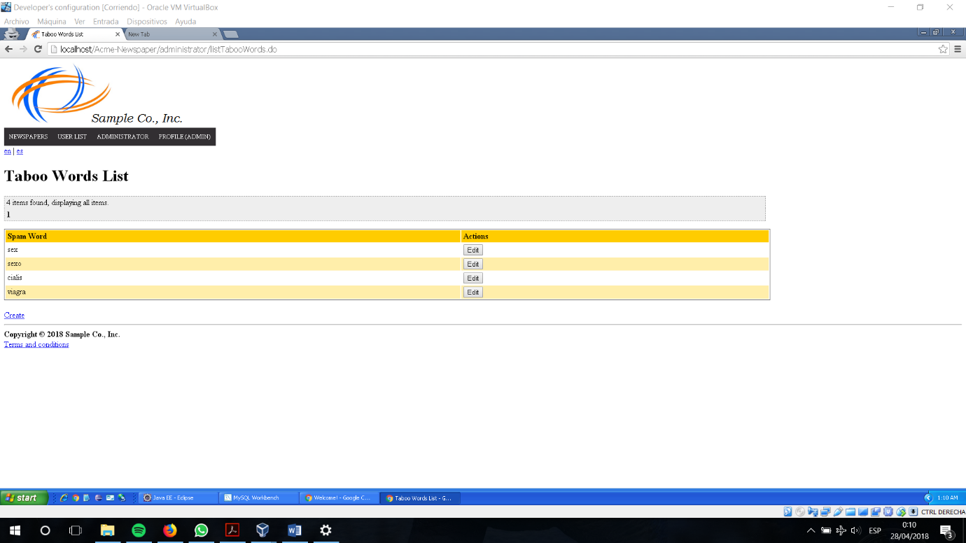

|  |  |
| --- | --- |
| **Test <#1>** | |
| **Description** | We want to see the default taboo words of the system. |
| **Expected** | We expect that they are going to appear four spam words: cialis, viagra, sexo and sex. |
| **Outcome** |  |
| **Notes** |  |

|  |  |
| --- | --- |
| **Test <#2>** | |
| **Description** | A non-authenticated user tries to enter by URL on the taboo words list. |
| **Expected** | We expect that the system must show the login view. |
| **Outcome** |  |
| **Notes** |  |

|  |  |
| --- | --- |
| **Test <#3>** | |
| **Description** | A login person who is not an administrator tries to enter by URL on the taboo words list. |
| **Expected** | We expect that the system must show a view explaining that he/she has not access to that view/resource. |
| **Outcome** |  |
| **Notes** |  |

# User case UC49 Display a private newspaper

Description

A login customer subscribed to a newspaper can see it with all the information referenced and the articles that it has.

Access

Login as Customer > Main menu > Newspapers > Newspapers > View

Tests

|  |  |
| --- | --- |
| **Test <#1>** | |
| **Description** | The subscribed customer can see the information of the newspaper and the article list. |
| **Expected** | The system must return a view with the title, description, publisher, the publication date and the list of articles with title, summary and creator. |
| **Outcome** |  |
| **Notes** |  |

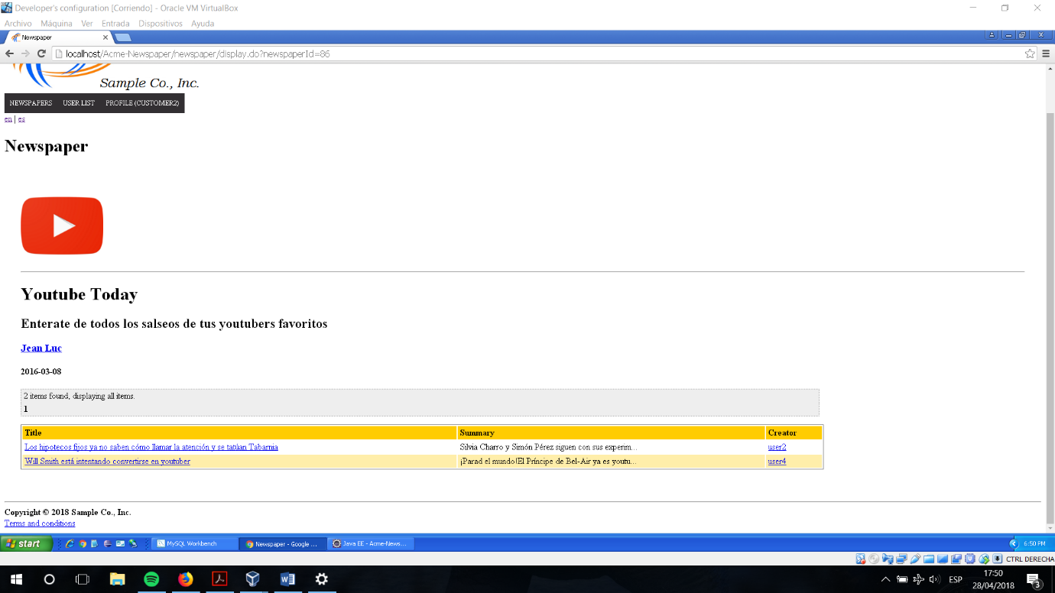

|  |  |
| --- | --- |
| **Test <#2>** | |
| **Description** | A login user or a non-authenticated actor can display a gelded private newspaper. |
| **Expected** | The system must return a view with the title, description, publisher, and the publication date. |
| **Outcome** |  |
| **Notes** |  |

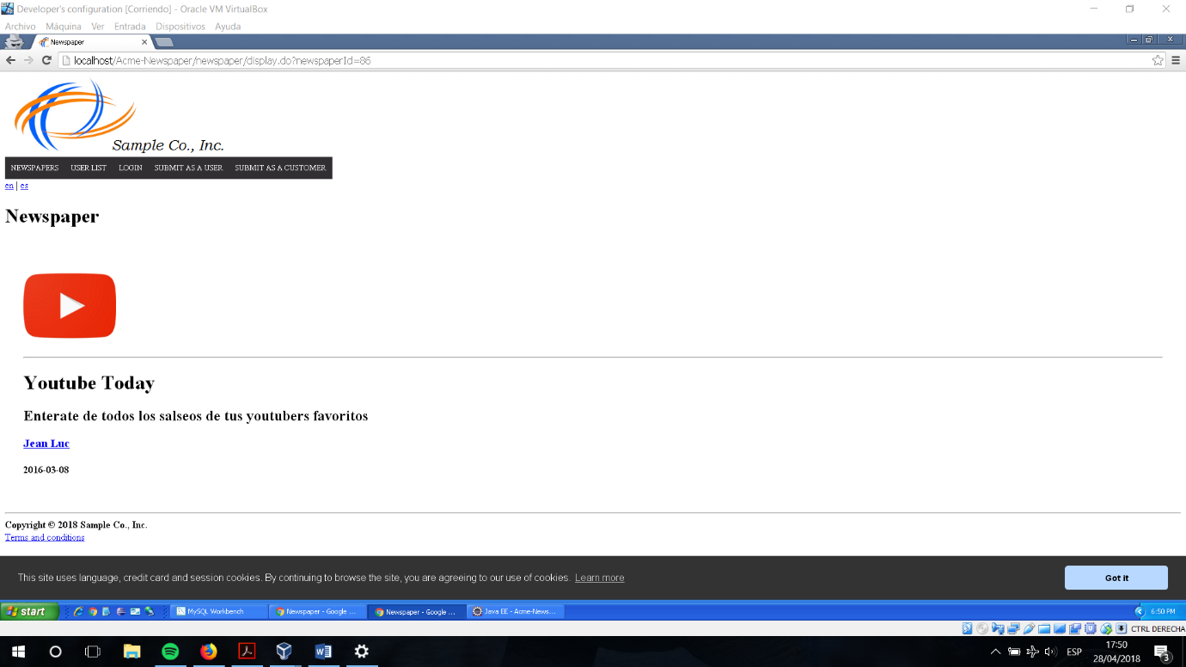

|  |  |
| --- | --- |
| **Test <#3>** | |
| **Description** | An administrator displays a private newspaper. |
| **Expected** | The system must return a view with the same information as if he/she were a non-authenticated actor, but including an extra button for deleting it. |
| **Outcome** |  |
| **Notes** |  |